PROJECT REPORT

SUPPLY CHAIN
&
INVENTORY ANALYSIS
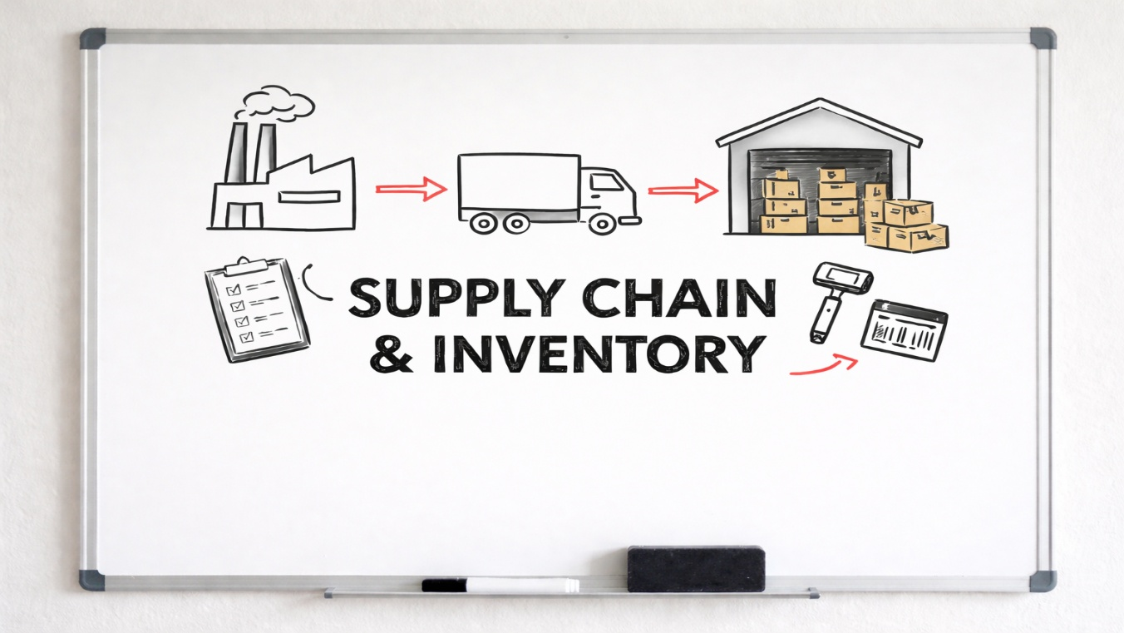

Name : Harish Raghavendraa G
Reg No : 727823TUAD036
Class : III Year AI&DS – ‘A’
Problem Statement:
A manufacturing company managing inventory across multiple warehouses is currently facing a dual crisis in supply chain efficiency.
- Observations indicate a critical imbalance: frequent stock-outs are causing delayed customer deliveries, while massive overstocking in other categories is driving up holding costs.
- Currently, inventory decisions are made manually without analytical support, leading to reactive rather than proactive management.
- This project aims to digitize the supply chain monitoring process, identifying specific products for immediate replenishment and pinpointing "cash traps" (overstock) to optimize working capital.

Project Objectives:
As a Supply Chain Analyst, the scope of this project involves:
- Data Transformation: Utilizing Power Query to clean warehouse data and calculate total stock values.
- Inventory Segmentation: Creating logic to classify products into "Low Stock," "Optimal," and "Overstocked" categories.
- Metric Calculation: Developing custom DAX measures for Inventory Turnover, Stockout Counts, and Holding Costs.
- Dashboarding: Engineering an interactive "Supply Chain Control Center" in Power BI to facilitate executive decision-making.

Tools & Technologies:
- Microsoft Power BI Desktop: For the development of the executive dashboard and action center.
- Power Query: Used for the ETL (Extract, Transform, Load) process and rigorous data cleaning.
- DAX (Data Analysis Expressions): Utilized for dynamic segmentation (Stock Status) and KPI calculations.
- Dataset: Logistics Warehouse Dataset, consisting of inventory levels, reorder points, and demand data across 4 Zones.
Data Preparation & Modelling:
Extensive data preparation was required to ensure the integrity of the analysis:
- Data Type Correction: Stock Levels and Reorder Points were validated as numeric values to allow for mathematical comparison.
- Calculated Columns: A logical column "Stock Status" was created to segment inventory:
  - IF Stock < Reorder Point → "Low Stock"
  - IF Stock > (Reorder Point * 2.5) → "Overstocked"
- Measure Creation: A custom DAX measure was implemented to track critical counts:
  - Count Low Stock = CALCULATE(COUNTROWS(Data), Stock_Status = "Low Stock")

Executive Summary (KPIs):
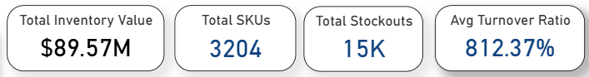
- Total Inventory Analysed: 3,204 SKUs.
- Critical Issue: Despite holding nearly $90M in inventory, the company experienced 15,000 stockouts, indicating a severe mismatch between supply and demand.
- Summary Insight: The supply chain is "Heavy but Hollow"—it has too much of the wrong stock (Overstock) and not enough of the right stock (Stockouts).

Analysis: Stock Health & Distribution:
Inventory Classification
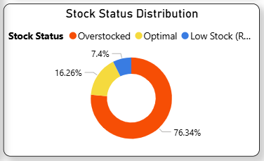

- Capital Trap: A staggering 76.34% of the inventory is classified as "Overstocked." This represents millions of dollars tied up in warehouse space that is not generating revenue.
- Risk Zone: Only 7.4% of items are in the "Low Stock" (Critical) phase, yet these items are responsible for the delivery failures.

Warehouse (Zone) Performance
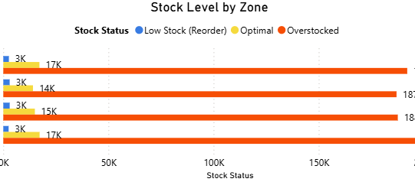
- Zone Analysis: Zone D holds the highest volume of inventory (~203K units), making it the primary location for excess stock accumulation.
- Shortage Hotspots: Zone A and Zone D both show visible segments of "Low Stock" items (approx. 3K items each), requiring immediate replenishment focus.
Demand vs. Supply Mismatch
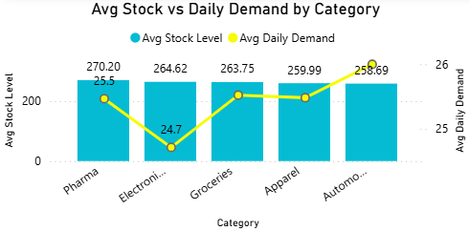
- Automotive: This category has the highest Average Daily Demand (26.0), making it the most sensitive to stockouts.
- Electronics: Shows the lowest daily demand (~24.7) relative to its stock levels, confirming it as a slow-moving category suitable for clearance.

Strategic Recommendations
Based on the data analysis, the following actions are recommended to the supply chain team:
- Immediate Replenishment (The "Red" List):
  - Approve emergency reorders for the 15 High-Demand SKUs identified in the Action Center (e.g., Groceries in Zone A) to stop the 15K stockouts.
- Liquidation Program:
  - Initiate a clearance sale for Electronics and Zone D overstock. Items like ITM11471 are costing nearly $986/day in holding costs and must be reduced.

- Reorder Point Optimization:
  - The high overstock rate (76%) suggests current reorder points are set too high. These should be lowered for slow-moving categories to reduce the $89.57M inventory value.
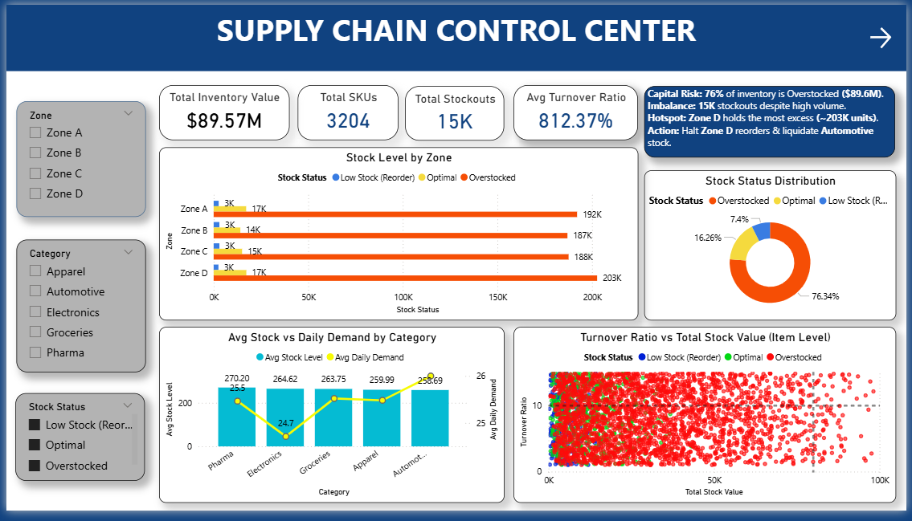
Dashboard

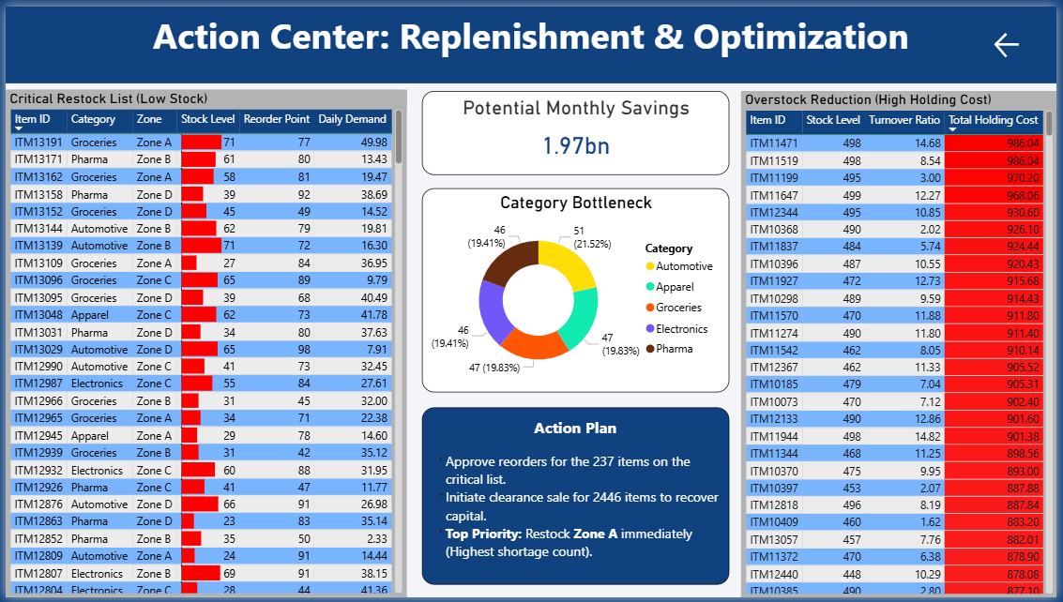
Conclusion
This analysis has successfully identified the root causes of the supply chain inefficiencies: a reactive stocking policy that has led to 76% overstocking while failing to meet demand for high-velocity items.
By executing the "Action Plan" developed in this dashboard—specifically targeting the Low Stock list for reorders and liquidating high-holding-cost items—the company can reduce working capital and eliminate stock-outs.

